Modeling Sleep/Wake Dynamics and Neurobehavioral Performance Impairment for Changes in Sleep Duration and Circadian Rhythm

Sleep is one of the most vital aspects of human life. Previous research has shown that for nearly all higher organisms, an “offline” period for the brain to rest is essential for several brain and bodily functions (Deboer et al.). Sleep re-energizes bodies after long days to achieve a full recovery by the next day. Sleep has been proposed as a two-process model, which posits that the interaction of a homeostatic process, depending on the prior amount of sleep and waking, with a process controlled by the circadian pacemaker, determines the main aspects of sleep regulation (Deboer et al.). The process of sleep homeostasis tells the body that the need for sleep is accumulating and that it is time to sleep, helping the body get enough sleep during the night to make up for the time being awake. 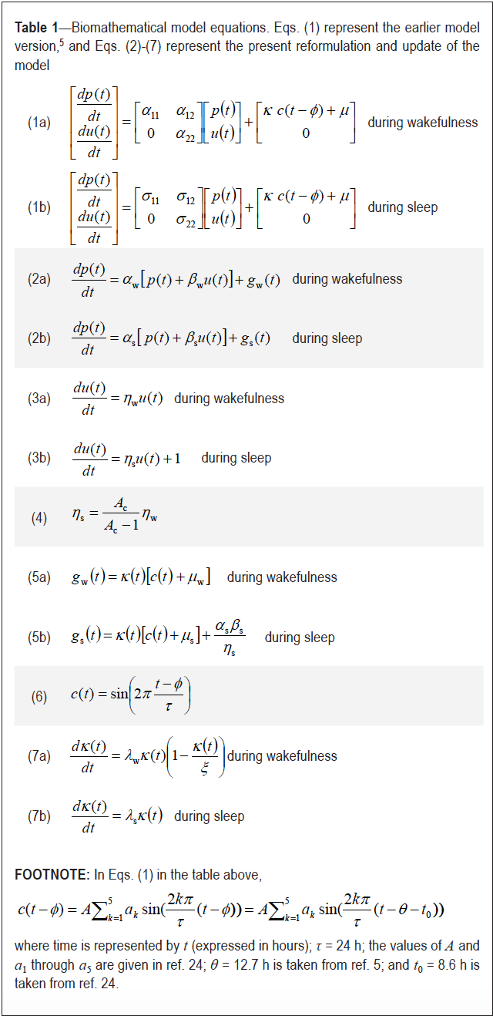

Sleep homeostasis does not function alone, however. The circadian biological clock regulates the timing of periods of sleepiness and wakefulness throughout the day. The biological circadian timing system is an endogenous system that evolved to allow organisms to anticipate changes in their natural environment (Zee et al.). Biological circadian systems rely upon zeitgebers, which are periodic factors in the environment, such as light, which help orient the biological rhythms. Circadian rhythms dip and rise during different parts of the day. Sleepiness that people experience during these circadian dips will be less intense if they had sufficient sleep, and more intense when they are sleep deprived. Similarly, during the circadian rhythm rises, people experience high alertness. The miniscule part of the brain that controls this phenomena is called the suprachiasmatic nucleus (SCN), which is a pair of nuclei located in the hypothalamus (Deboer et al). When light, a sign of daylight, hits the eye, the optic nerve sends signals to the SCN. The SCN then signals different parts of the brain that control hormones, body temperature, and other functions that help the body feel awake (Deboer et al).

This entire process only works smoothly if one is getting sufficient and regular sleep. However, in the reality of today’s busy life, sleep schedules are often disrupted by situations like having immense amounts of stress or flying to a different time zone. Additionally, the prevalence of blue light in computer screens can stimulate the SCN. As a result, circadian rhythm can very easily be thrown off, hindering task performance throughout the day.

A study done by McCauley et al., “Dynamic Circadian Modulation in a Biomathematical Model for the Effects of Sleep and Sleep Loss on Waking Neurobehavioral Performance” attempts to create a mathematical model to predict the effect of sleep deprivation and circadian misalignment on fatigue, behavioral alertness, and performance. This 2013 article is an article where the authors improve their original model (Eqns. 1a and 1b in Table 1), published in 2009. Their goal was to better model the impact of time-dependence in the amplitude of the circadian modulation of performance and to account for possible oscillations. The original model only focused on temporal dynamics between sleep and wake cycles across days. The dynamics of waking neurobehavioral performance within sleep/wake cycles were driven by an emergent property involving nonlinear interaction between the homeostatic process described by the homogenous part of the differential equations and circadian process encompassed in a non-homogeneous part.

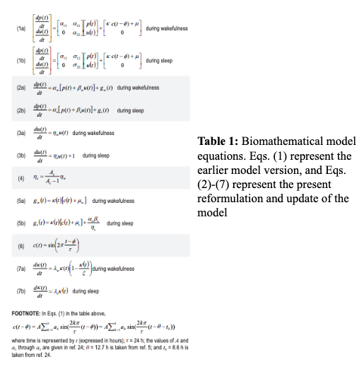

In the new model, the authors got rid of the constraint for the non-homogenous part of the ODEs to contain only oscillatory functions, thereby generalizing the applicability of the model to include night shift schedules and nap sleep scenarios. Using data from three different studies of sleep duration and neurobehavioral performance in human subjects, the authors estimated the parameters of the model. First, the authors created two first-order ordinary differential equations (equation 2) with the dependent variables of *p* and *u* to model waking neurobehavioral performance for people with various types of sleep schedules and habits. *p* measures performance impairment over time. *p* rises in a saturating exponential manner towards an upper asymptote during wakefulness and falls exponentially towards a lower asymptote during sleep. The function *u* modulates the sleep homeostatic equilibrium over time. During wakefulness, *u* produces a slow exponential increase of the asymptote towards which *p* rises, and vice versa when *p* falls. They were able to incorporate the circadian dynamics into the system of ODEs by adding *gw* and *gs*(Eqns. 5a and 5b in Table 1), where *w* indicates the wakeful state and *s* indicates sleep. They represent the non-homogeneous part of the ODE system, which includes circadian rhythm. These two equations contain *c*(*t*) (Eqn. 6 in Table 1), which is a time dependent function that helps to represent the circadian process.

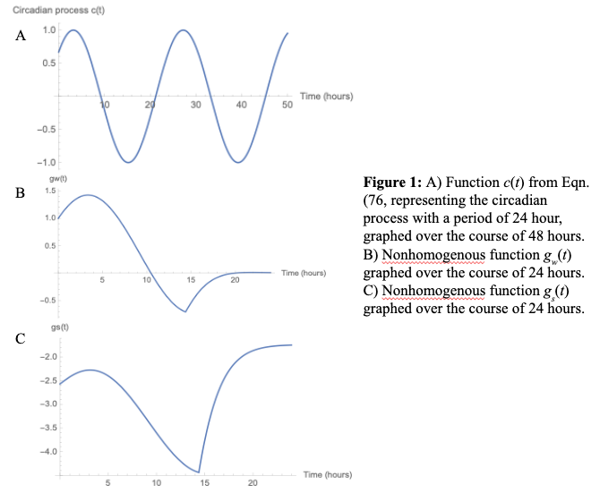

This model of neurobehavioral performance during the sleep/wake cycle can be used to analyze performance given different amounts of time spent sleeping. This model presents two different sets of ODEs – one set models performance during wakefulness, and the other set models performance during sleep. In the authors’ updated model, they eliminated the sleep/wake discontinuity, allowing for a better modeling of the transition between sleep and wakefulness.

To simulate switching between these two states, the *squarewave* function was used. *Squarewave* is a periodic function that is sometimes 1 and sometimes 0, and the proportion of the time when *squarewave* equals 1 can be controlled. Therefore, the proportion of time awake and time sleeping can be controlled by turning the wakeful and sleep equations “on” and “off.”

To test how this model demonstrates performance impairment, different proportions of

time awake were used to see the varying results with differing wakefulness cycles:

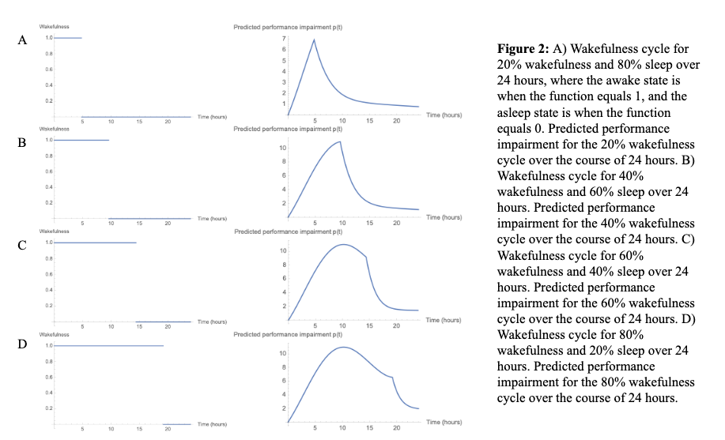

Figure 2 displays graphs of predicted performance impairment (*p*) with different wakefulness cycle over 24 hours. Generally, *p* rises in a saturating exponential manner towards an upper asymptote during wakefulness and falls exponentially towards a lower asymptote during sleep. However, in the 60% and 80% wakefulness cycles, there are times when the performance impairment decreases, despite being awake for a long time. This can be attributed to the oscillations of the circadian rhythm. The sleep/wake homeostasis may be indicating that the body is tired, but circadian rhythm may be at its peak, telling the body that it is time to be awake. Like mentioned previously, sleep is regulated by two body systems, so even if one system is decreasing, the other system may be increasing, allowing the performance impairment to decrease. As a result, it can be concluded that this model does account for how staying awake for long periods of time leads to performance impairment and how the circadian rhythm allows a person to be less affected by fatigue after being awake for a long time.

If a person constantly sleeps the same amount of time over a long time period, the circadian rhythm will adjust to the new schedule. Figure 3 displays the graphs for when people maintain a constant sleep schedule for 2 weeks.  
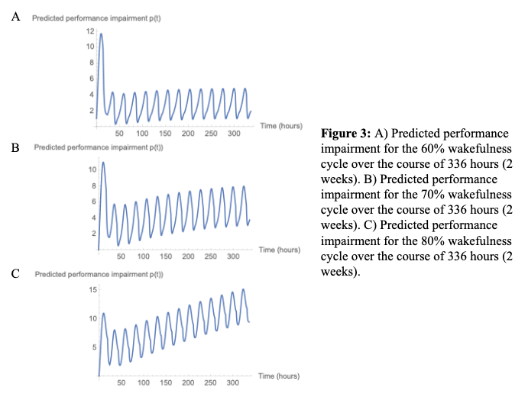

For the 60% wakefulness cycle, it is evident that the performance impairment is high in the beginning days, but it decreases and oscillates constantly as the days go on. This is an indicator of how one may feel the effects of performance impairment of the new sleep schedule but adjusts to it over time, allowing for lower effects on performance as time passes. A similar phenomenon occurred for the 70% and 80% wakefulness cycles, but their oscillations increased as time passes. This is reasonable because prolonged sleep deprivation will take a toll on an individual. Consequently, the increase in performance impairment over the course of 2 weeks, despite the initial decrease, can be seen in the figures.

There are also instances where a person may have a certain sleep schedule for one week, but a different one for the other, as displayed in Figure 4.

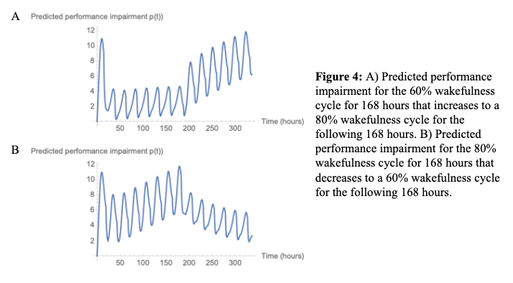

Figure 4A demonstrates the performance impairment when an individual has one week of sufficient sleep but has insufficient sleep the next week. The oscillations were as expected, for the performance impairment was low in the first week, but slowly started to increase as the sleep deprivation started to affect the individual. The second figure is the other way around, where the individual starts with a sleep schedule with very little sleep and increases the time in bed the next week. The performance impairment decreases at first, trying to adjust to the lack of sleep, but increases as the week progresses due to the accumulation of fatigue. However, as the sleep schedule changes to a healthier one, the performance impairment gradually decreases in the second week.

One of the main applications of circadian rhythm research is in the field of transportation. When humans travel eastward and westward and cross time zones, their circadian rhythms are often shifted, sometimes dramatically. For both military and civil purposes, it is important to model the neurobehavioral performance impairment that occurs when traversing these time zones and undergoing circadian shifts, known more commonly as “jet lag.” A better understanding of this impairment, specifically how severe the impairment is and how long its effects are, can offer potential mechanisms for reducing performance impairment and improve how humans can adjust to new circadian rhythms.

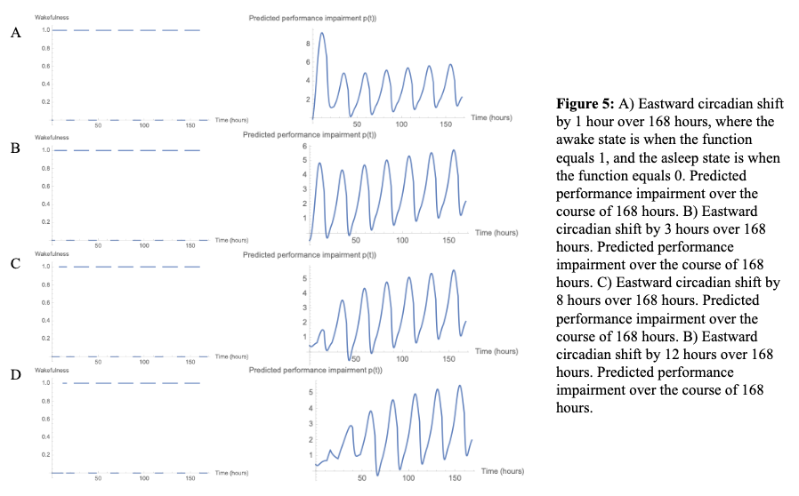

Firstly, eastward jet-lag was examined for a sleep/wake cycle set to spend 8 hours sleeping and 16 hours awake, displayed in Figure 5. Operating on the assumption that eastward travel loses an hour of daylight (waking time) per time zone crossed, the initial waking period of 16 hours was set to lose an hour per time zone crossed, following 8 hours of sleep, then starting a regular cycle of 16 hours of wakefulness that continues for the next 6 days. This was achieved by using the *squarewave* function to model the amount of time sleeping and waking, as previously described, and the *HeavisideTheta* function to turn on the regular cycle after the time-zone shift. The *HeavisideTheta* function is 1 when the input is positive, and 0 when the input is negative, so it can be turned “on” and “off” after a certain time.

The performance impairment of a one-hour eastward shift was analyzed first. Figure 5A represents a 1-hour shift after 24 hours, and the shifted sleep/wake cycle for the next 144 hours (6 days). The wakeful state exists wherever the function in Graph 7.17 equals 1, and the sleep state exists when the graph equals 0. Predicted performance impairment was analyzed over this shifted sleep/wake timing for a week after the shift (Figure 5A). Performance impairment initially spikes, resembling the non-shifted cycles in Figure 3. Predicted performance impairment then settles into oscillations where impairment rises during wakefulness and falls during sleep. The oscillations then begin to shift slightly upwards over time, indicating that impairment increases over time. However, these oscillations remain fairly steady and closely resemble the oscillations seen in the 60% and 70% awakeness cycles in Figure 3, which suggests that humans are able to recover quickly from that the one-hour shift, and there is not a significant increase in performance impairment from the shift.

Next up was a longer, but still relatively small shift of 3 hours, the difference in time for a traveler from New York to Los Angeles. Figure 5B represents the sleep/wake cycle for this 3-hour shift. Predicted performance impairment spikes initially, but similarly settles into oscillations where impairment increases during wakefulness and decreases during sleep. Like the 1-hour shift, the oscillations remain steady but slightly increasing.

For an even longer shifts of 8 and 12 hours, predicted performance impairment starts out at a low peak, then settles into large and regular oscillations. These oscillations remain steady and shift slightly upward, in a pattern similar to the previous shifts. The initial low peak is likely due to the longer amount of sleep at the beginning of the shifted cycle. However, the 8 hour and 12 hour shifts produce regular oscillations after a longer period of time. This indicates that these shifts impair the ability of humans to settle back into the normal sleep/wake oscillations. However, for these shifts, the performance impairment tends to increase over time. This is counterintuitive – as the body settles back into a normal rhythm after a shift interruption, it’s expected that the performance impairment will decrease back to normal levels. A slight increase in the oscillations is likely due to the impairment in performance due to insufficient sleep of 8 hours in the cycle, but this may not be able to account for all of the increase. Despite the slight insufficiency of this rest period, most healthy adults sleep for about 8 hours; the model for jet lag should closely resemble the actual sleep of adults who travel to provide the most accurate results. This suggests that this model, in its current form, may not be able to completely accurately represent impairment as a result of shift changes, and future work is needed to adapt the model to these scenarios.

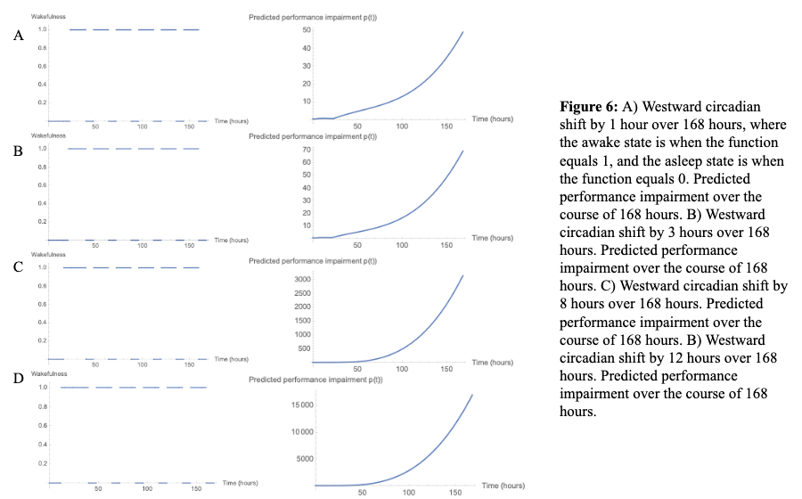

In a similar manner, westward jet lag situations were then analyzed for 1-hour, 3-hour, 8-hour, and 12-hour shifts in circadian rhythm, as displayed in Figure 6. However, the predicted performance impairment for each of these circadian shifts did not display any major oscillations and increased exponentially with time. Again, this is extremely counterintuitive, as previous data indicates that performance impairment should decrease over time as the body adjusts to the new circadian rhythm, or increase at a very slow rate, due to insufficient sleep. The inability of this model to accurately depict these circadian shifts represents a high demand for model improvements to better model travel and its effects on humans.

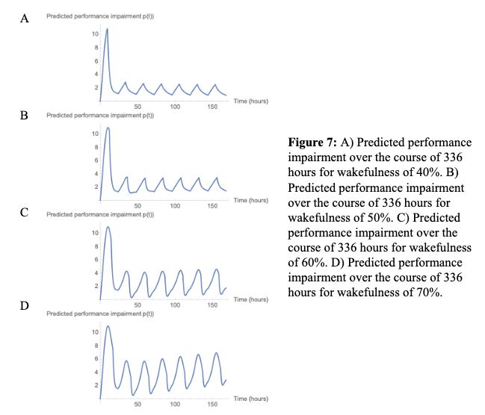  
 When analyzing the behavior of performance impairment over time for various sleep cycles, a trend seemed to emerge. For a sleep cycle where wakefulness is 70% of the time (Figure 7D), the oscillations shift upwards over time, suggesting that the harmful effects of sleep deprivation cause performance impairment that builds up. This suggests that 30% sleep (7.2 hours) is insufficient for the body to regenerate after 70% of the time spent awake. Figure 7C displays the performance impairment for a cycle of 60% wakefulness. These oscillations still appear to shift upwards, but much less than the oscillations in Figure 7D. This implies that 9.6 hours of sleep is very close to sufficiently refreshing the body after 14.4 hours of being awake. In Figure 7B, the performance impairment for a cycle of 50% wakefulness oscillates, and they don’t shift, indicating that 12 hours of sleep is sufficient. These results from the McCauley et al. model suggest that 9.6 or more hours of sleep are necessary to eliminate all performance impairment and that this value represents a bifurcation – less than 9.6 hours makes performance impairment unstable, and more is stable.

Through this project, the mathematical machinery created by McCauley et al. to analyze the neurobehavioral performance based on sleep was used to analyze several different sleep/wake cycles and circadian shifts. The model was successful in demonstrating the performance impairment effects from sleep deprivation over 24-hour periods and 2-week periods. Generally, the more time in bed an individual has, their performance becomes less impaired. However, since sleep is divided into two different systems, the circadian rhythm of an individual may help them feel less fatigued, lessening the effects on performance. By utilizing this machinery from the McCauley model, ~9.6 hours was identified as a bifurcation for the stability of performance impairment. Additionally, the machinery was used to analyze several possible scenarios of jet lag, for both westward and eastward travel. The machinery was unable to predict performance impairment for westward circadian shifts, but better able to model predicted performance impairment for circadian shifts from eastward travel. These results highlight the demand for a better model to account for these circadian shifts. Better analysis of the performance impairment from inter-time-zone travel will allow prediction of how long the effects of jet lag will last, and this better understanding may allow for potential treatment to mitigate the negative effects. As the model is updated, the parameters must be estimated again and fit to more data from a variety of more studies on sleep, to maximize its accuracy and for the types of scenarios it can be applied to (jet lag, nap scenarios, night shift work, etc). This model also does not account for the effects of light, and how bright light stimuli at certain times could affect circadian rhythm and performance. Light treatment and management is a promising way to help the body adapt to shifts in circadian rhythm (Monk). Overall, this model provides promising results for analysis of several different sleep scenarios but must be updated to be more relevant to even more situations of the busy and ever-awake world.

**References**

Deboer, T. (2018). Sleep homeostasis and the circadian clock: Do the circadian pacemaker and

the sleep homeostat influence each other’s functioning? Neurobiology of Sleep and

Circadian Rhythms, 5, 68-77.

Mccauley, P., Kalachev, L., Mollicone, D., Banks, S., Dinges, D., & Van Dongen, H. (2013).

Dynamic circadian modulation in a biomathematical model for the effects of sleep and

sleep loss on waking neurobehavioral performance. Sleep, 36(12), 1987-1997.

Monk, T. (2010). Enhancing Circadian Zeitgebers. Sleep, 33(4), 421-422.

Zee, P., & Manthena, P. (2007). The brain's master circadian clock: Implications and

opportunities for therapy of sleep disorders. Sleep Medicine Reviews, 11(1), 59-70.